Chapter 8: Gravity

8.1 Earth’s gravity pulls objects to the centre of the Earth

Student worksheet answers (pages 144–145)

Gravity

1 Write the definition of the following words:

a gravity

Gravity is the force that attracts an object to the centre of the Earth.

b gravitational field

The gravitational field is the area around a body in which another body experiences a force of attraction.

c weight

Weight is a measure of how much gravity is pulling an object

d mass

Mass is how many particles or atoms make up an object.

e newton

A newton is the unit used to measure force.

Isaac Newton is pictured below on the day he first pondered the idea of gravity.

2 Using the diagram, explain why the apple fell to the ground.

The apple fell to the ground because of gravity, which attracted the apple to the Earth.

3 The apple has a mass of 200 grams. Using the diagram of the bricks as a guide, what would its weight be:

a on Earth?

0.2 kg × 9.8 N = 1.96 N

b on the Moon?

0.2 kg × 1.6 N = 0.32 N

c on Jupiter?

0.2 kg × 23.6 N = 4.72 N

4 Assuming Newton’s mass was 60 kilograms, what was his weight:

a on Earth?

60 kg × 9.8 N = 588 N

b on the Moon?

60 kg × 1.6 N = 96 N

c on Jupiter?

60 kg × 23.6 N = 1416 N

5 In the space provided, draw a labelled diagram to explain why a tennis ball and a cricket ball would hit the ground at the same time when dropped from the same height.

The labelled diagram should include a tennis ball and a cricket ball, both with arrows pointing towards the ground. The explanation could be along the lines of the following: the heavy cricket ball needs more force to start it moving than the lighter tennis ball, this offsets the larger gravitational pull on the cricket ball, so both balls hit the ground at the same time.

EXTEND YOUR UNDERSTANDING

6 What were another five discoveries made by Sir Isaac Newton?

Student responses will vary but could include the following:

• the three laws of motion

• he predicted that the Earth was most an oblate spheroid shape

• he contributed to the study of power series (in mathematics)

• he observed that colour was a property of light in a series of experiments using prisms

• he explained the trajectories of comets

• he explained ocean tides

8.2 Gravity keeps planets in orbit around the Sun

Student worksheet answers (pages 146–147)

Gravitational orbit

1 Use the information from the two diagrams below to explain the reason why the Moon orbits the Earth:

The Moon tries to move forward, past the Earth, but the force of the Earth’s gravity tries to pull the Moon towards the Earth. The result is a balance of forces pushing the Moon out and pulling the Moon in, resulting in the Moon orbiting the Earth.

2 The Moon moves away from the Earth by approximately 3.7 cm per year. How far has it moved:

a since you were born?

Student responses will vary, but for a 12 year old it would be 44.4 cm and for a 13 year old it would be 48.1 cm.

b since either of your parents was born?

Student responses will vary

c since any of your grandparents were born?

Student responses will vary

3 If the Sun’s mass is 1000 times greater than that of Jupiter, and Jupiter’s mass is 317 times greater than that of the Earth, how much greater is the Sun’s mass than the Earth’s?

The Sun’s mass is approximately 317 000 times greater than that of the Earth.

EXTEND YOUR UNDERSTANDING

4 In addition to confirming that the Earth travelled around the Sun, what were another three discoveries made by Galileo Galilei?

Student responses will vary but could include the thermoscope (an earlier thermometer), a telescope with magnification up to approximately ×30 and the discovery of three of Jupiter's four largest satellites or moons.

8.3 The Moon’s gravity causes tidal movements

Student worksheet answers (pages 148–149)

Tidal movement

1 The diagram below illustrates the influence that the Moon and the Sun have on the Earth’s tides. Fill in the boxes to explain the creation of tides (the orange bulge represents the Moon’s gravitational pull and the yellow bulge represents the Sun’s gravitational pull)

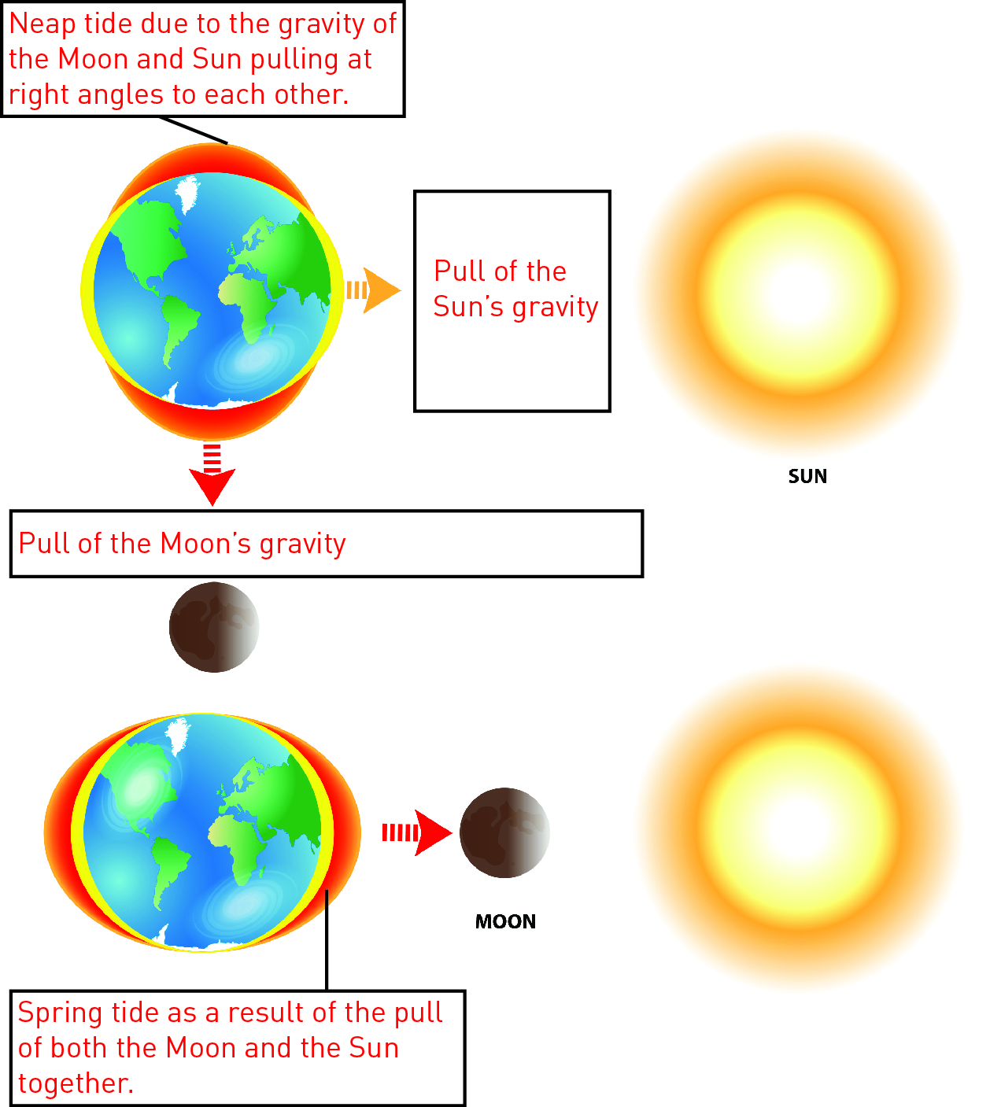

2 Even though the Sun is enormous compared with the mass and size of the Moon, the Moon has a greater effect on tides. Even though the Sun’s mass is 27 million times bigger than the Moon’s, it is 400 times further away from the Earth than the Moon. As a result, the Moon’s force is approximately 59 million greater than that of the Sun.

Use the information above and the calculation below work out the difference in tide-causing force.





Percentage of Sun’s v. Moon’s effect of tides = 0.46 × 100

Percentage of Sun’s v. Moon’s effect of tides = 46%

3 Do you think that spring tides only occur during the season of spring? Try to explain the reason for your answer.

Student responses may vary, but they should realise there is no connection between spring tides and spring because spring tides occur according to the phases of the Moon, whereas seasons occur according to the Earth’s orbit around the Sun.

EXTEND YOUR UNDERSTANDING

4 The cycles of the Moon can affect more than just the tides, especially when it is a full Moon. Research another four effects of a full Moon.

Student responses may vary but could include that animals may be more active because of the brightness of the night. Certain insects are more active during a full Moon. Sleep can also be affected during a full Moon because of the brightness of the night.

8.4 Science as a human endeavour: Scientists work collaboratively to explore microgravity

Student worksheet answers (pages 150–151)

Microgravity

1 Write four interesting facts about the International Space Station (ISS).

• The ISS was assembled in space

• The ISS travels at a speed of 27 700 km/h

• The ISS has 14 sections with laboratories and living quarters.

• Scientific research is being done in biology, physics, astronomy and meteorology.

2 Label the picture with a summary of the effects of microgravity that the astronaut may experience.

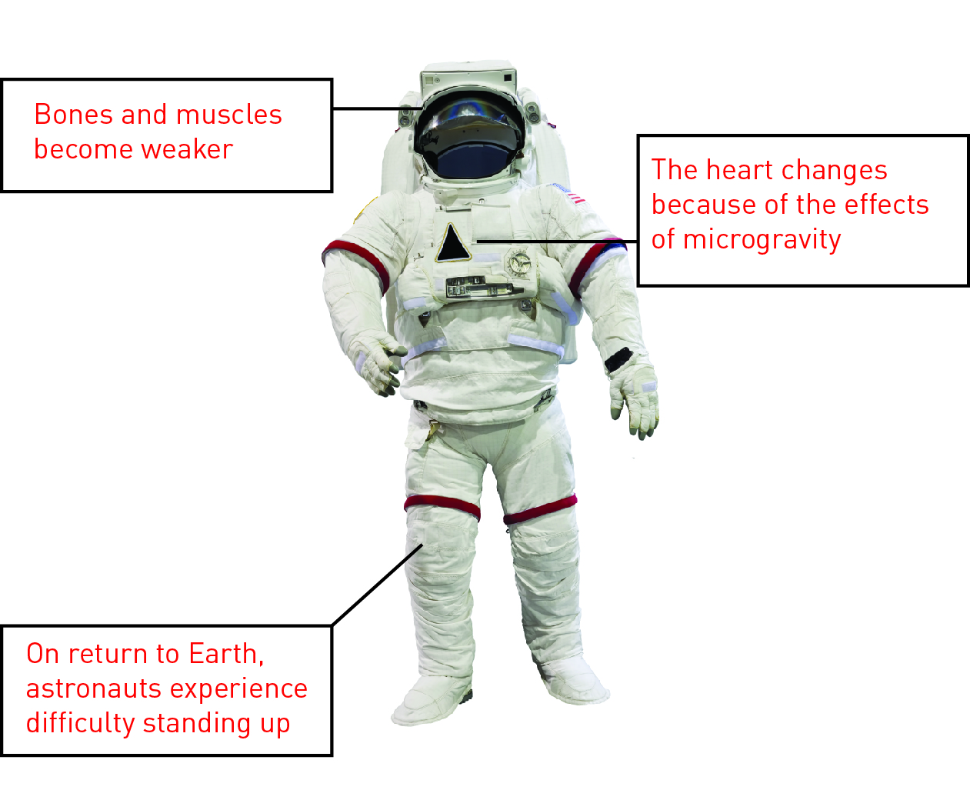

3 Research another two effects of microgravity and add these to the diagram above.

Other effects of microgravity include: redistribution of body fluids away from the lower extremities (legs) to the upper part of the body; astronauts becoming a little taller while in space; and motion sickness because of the effects of microgravity on the inner ear.

EXTEND YOUR UNDERSTANDING

4 Is there evidence of life on Mars? Undertake some research and write a brief summary of what you find out.

Student responses will vary but could include the fact that the methane and organic compounds found on Mars could have been produced by life forms rather than coming from meteorites or interstellar dust. Other geological features on the planet’s surface suggest that water once flowed on its surface. More information can be found at <https://cosmosmagazine.com/space/life-mars-%E2%80%93-evidence-mounts>